Lab: Lab 4 – VHDL Design of ALU and its FPGA Implementation
Name: Solomon Ewusi | Student ID: N01659373
Date: October 19, 2026

Please refer to the lab manual posted on the blackboard and fill in the blanks in the following table as your lab report.
Notice: All labs are individual work and submission. All academic misconduct behaviors will be penalized to the maximum extent possible according to college policy. Thanks for your attention. (Reference Link: About Academic Misconduct)
Fill in all the lab report submission requirements in the following table. Please add more rows if necessary.

Requirements | Your submissions (Answers/Source Code/Screenshots/File Submissions, etc.)  Please notice: If it is required to submit a separate file, please attach it separately on the blackboard.
Professor’s demo signature marked on the attendance sheet? (demo the mux code in the first week and demo the circuit testing on the training board) | The ALU circuit was implemented and tested on the BASYS 3 FPGA training board. Photos of the board test results for all 8 functions are included in the last row of this table as proof of the demonstration.
Your VHDL source codes (ALU.vhd and Mux.vhd) | ALU.vhd and Mux.vhd are submitted as separate files on Blackboard.
Screen shots of simulation runs for at least 360ms (please make the screen in full window size by clicking the button). | 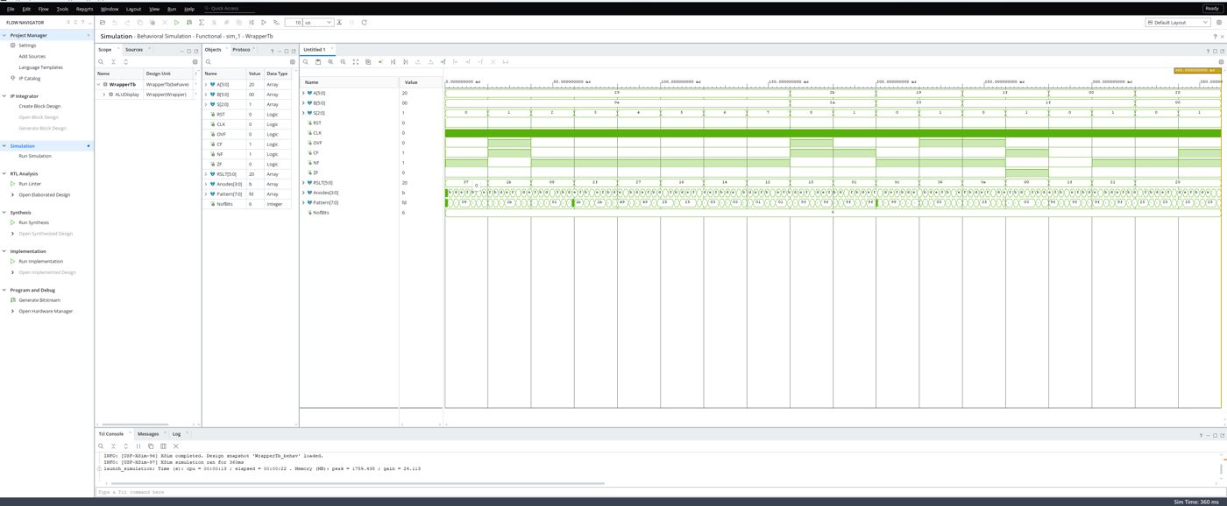  Screenshot 1: Full behavioral simulation, 0 – 360 ms (values in hexadecimal)  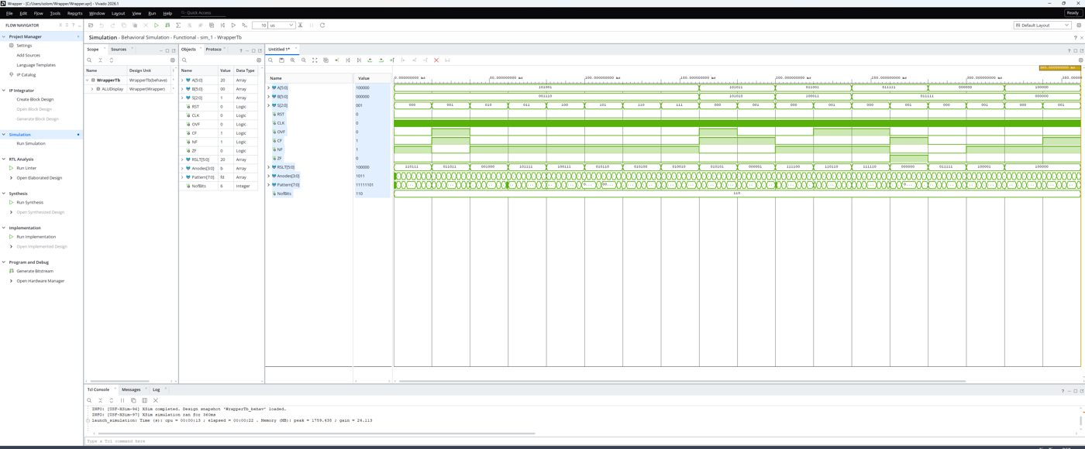  Screenshot 2: Same simulation with A, B and RSLT shown in binary  Explanation: The testbench (WrapperTb.vhd) was run for 360 ms, as shown by "XSim simulation ran for 360ms" in the Tcl Console. For the first 160 ms, A = 101001 and B = 001110 are held constant while S steps through all 8 codes (20 ms each), so every ALU function is tested once:  From 160 ms to 360 ms the testbench repeats add (000) and subtract (001) with new input pairs to check the condition flags. For example, 011111 − 011111 = 000000 sets ZF = 1, and 100000 + 000000 = 100000 sets NF = 1. All simulated results match the expected values, which confirms the ALU works correctly.
  S | Function | RSLT (binary) | Decimal
  000 | A + B | 110111 | −9
  001 | A − B | 011011 | 27
  010 | A AND B | 001000 | 8
  011 | A OR B | 101111 | −17
  100 | A XOR B | 100111 | −25
  101 | NOT A | 010110 | 22
  110 | Shift A right | 010100 | 20
  111 | Shift A left | 010010 | 18
Final results of the circuit testing on the FPGA board.
S (SW 2 to 0) | A (SW 15 to 10) | B (SW 9 to 4) | Display on LEDs
000 | 110100 | 111010 | −18 (LEDs 101110)
001 | 110100 | 111010 | −6 (LEDs 111010)
010 | 110100 | 111010 | −16 (LEDs 110000)
011 | 110100 | 111010 | −2 (LEDs 111110)
100 | 110100 | 111010 | 14 (LEDs 001110)
101 | 110100 | 111010 | 11 (LEDs 001011)
110 | 110100 | 111010 | 26 (LEDs 011010)
111 | 110100 | 111010 | −24 (LEDs 101000)
Board test photos
Inputs set on the switches for every test: A = 110100 (SW15–SW10), B = 111010 (SW9–SW4); only S (SW2–SW0) changes. LD15–LD10 show RSLT in binary, LD3–LD0 show CF, NF, OVF and ZF, and the 7-segment display shows RSLT as a signed decimal number. All 8 results on the board match the simulation and the expected values.
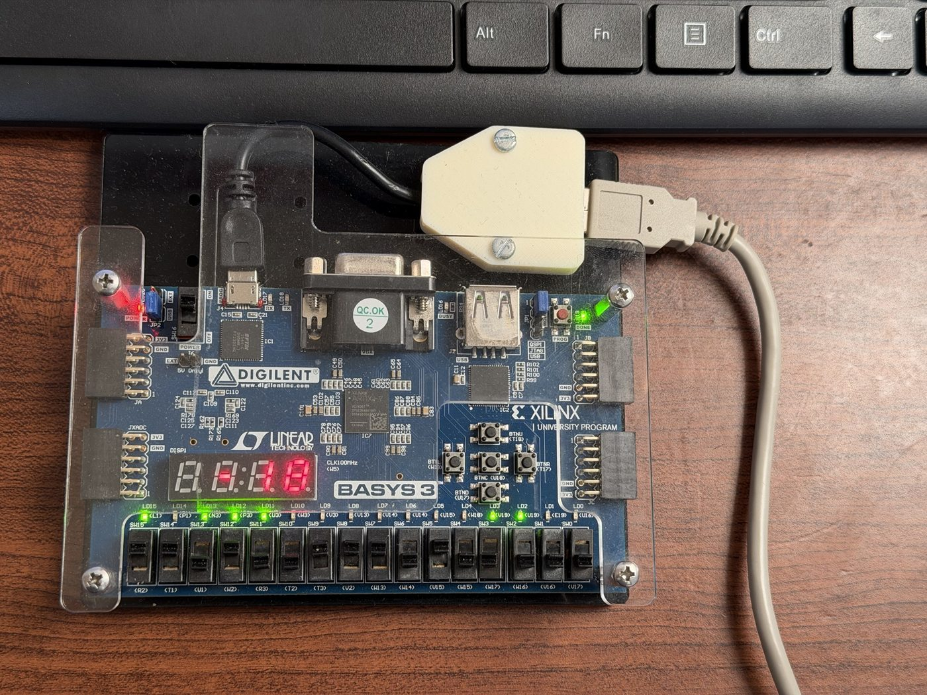  000 – A + B: display −18 | 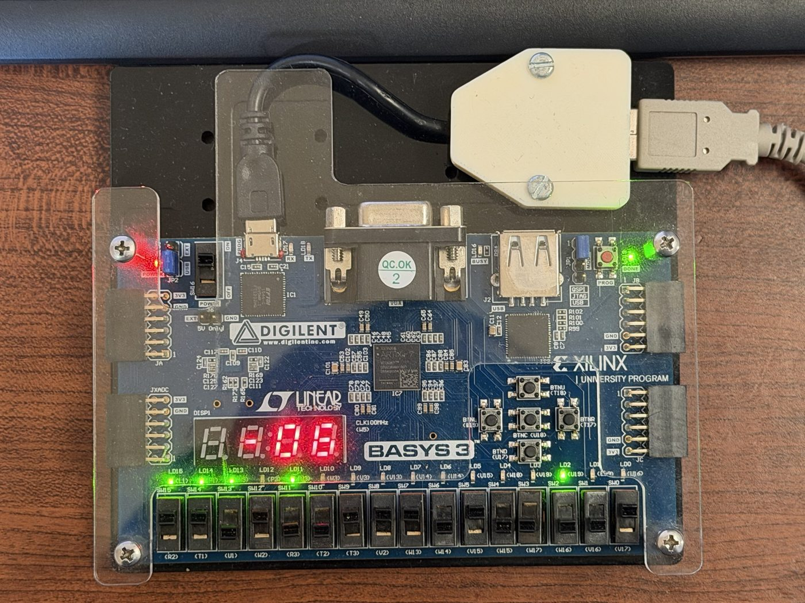  001 – A − B: display −6
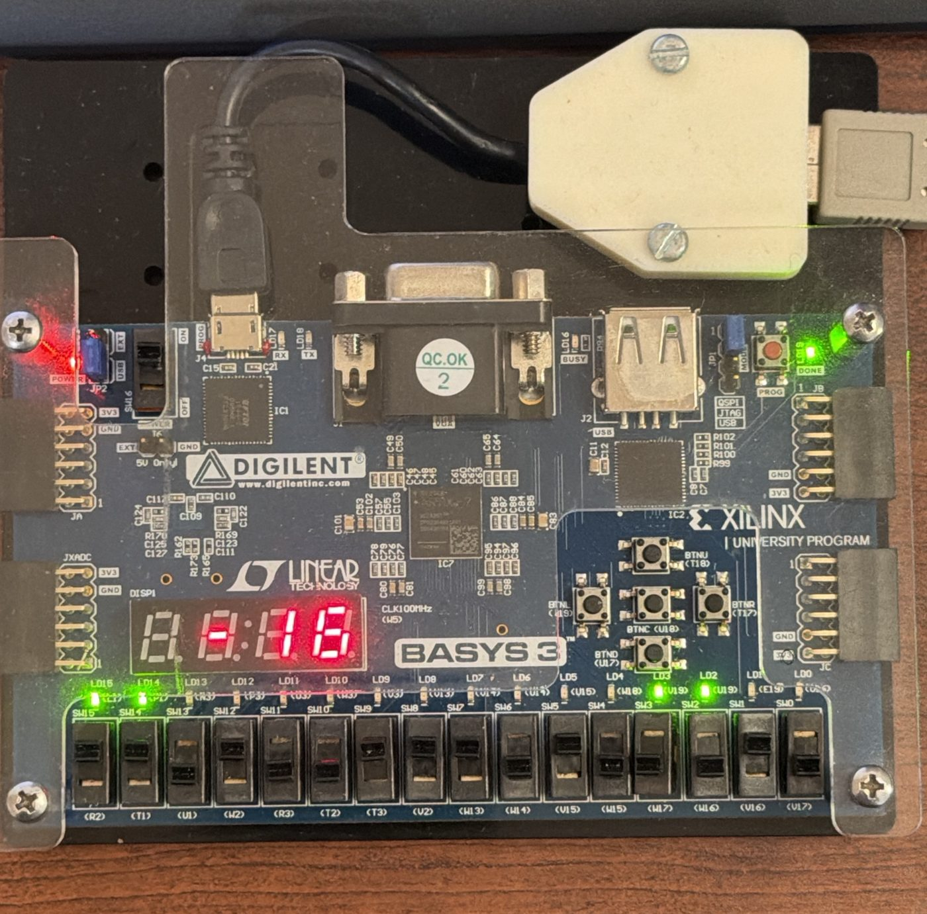  010 – A AND B: display −16 | 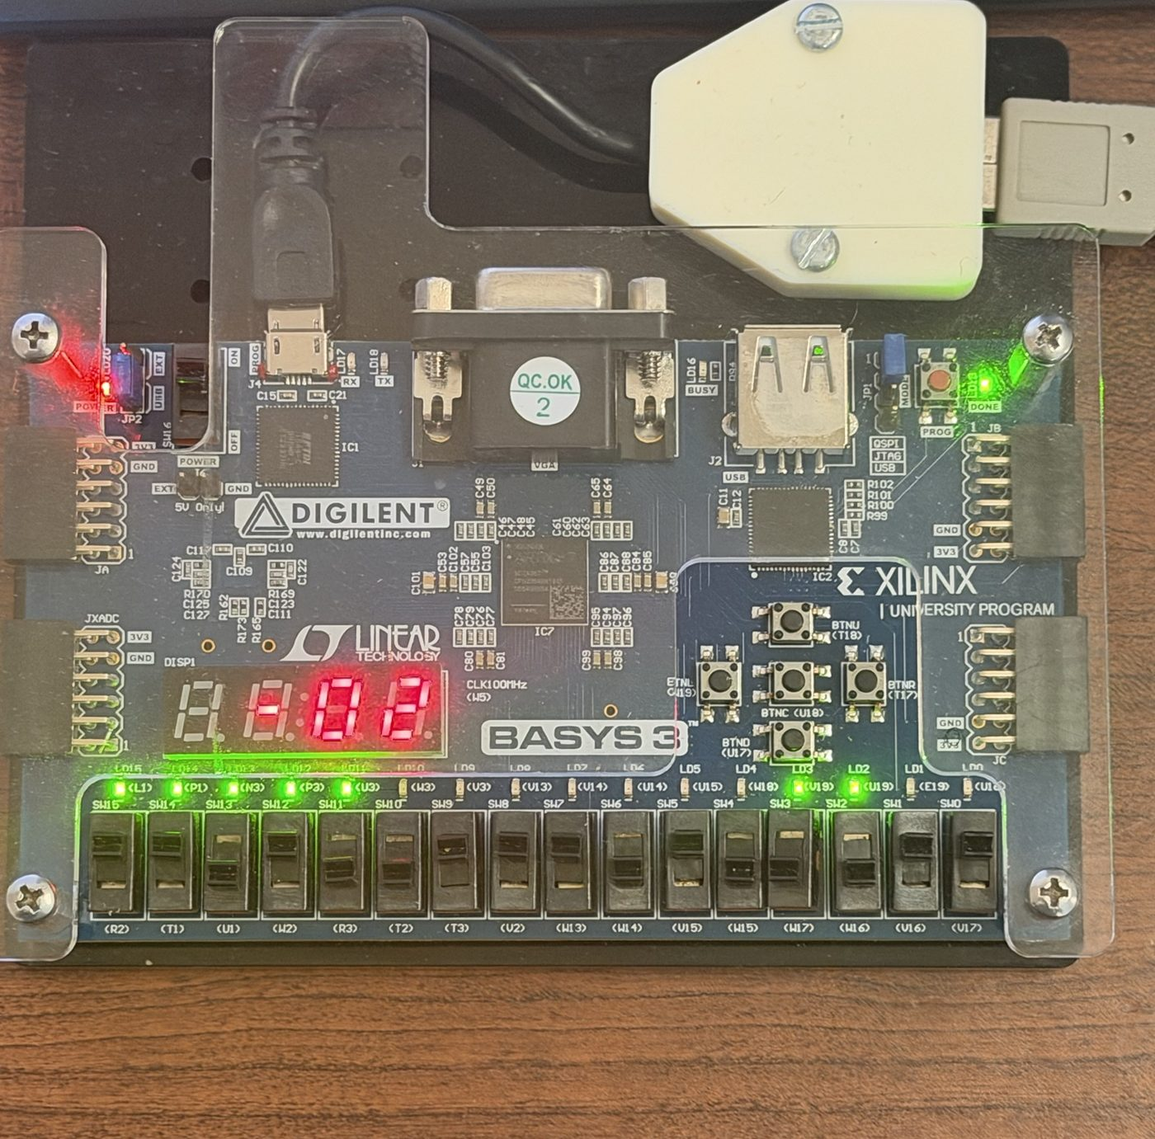  011 – A OR B: display −2
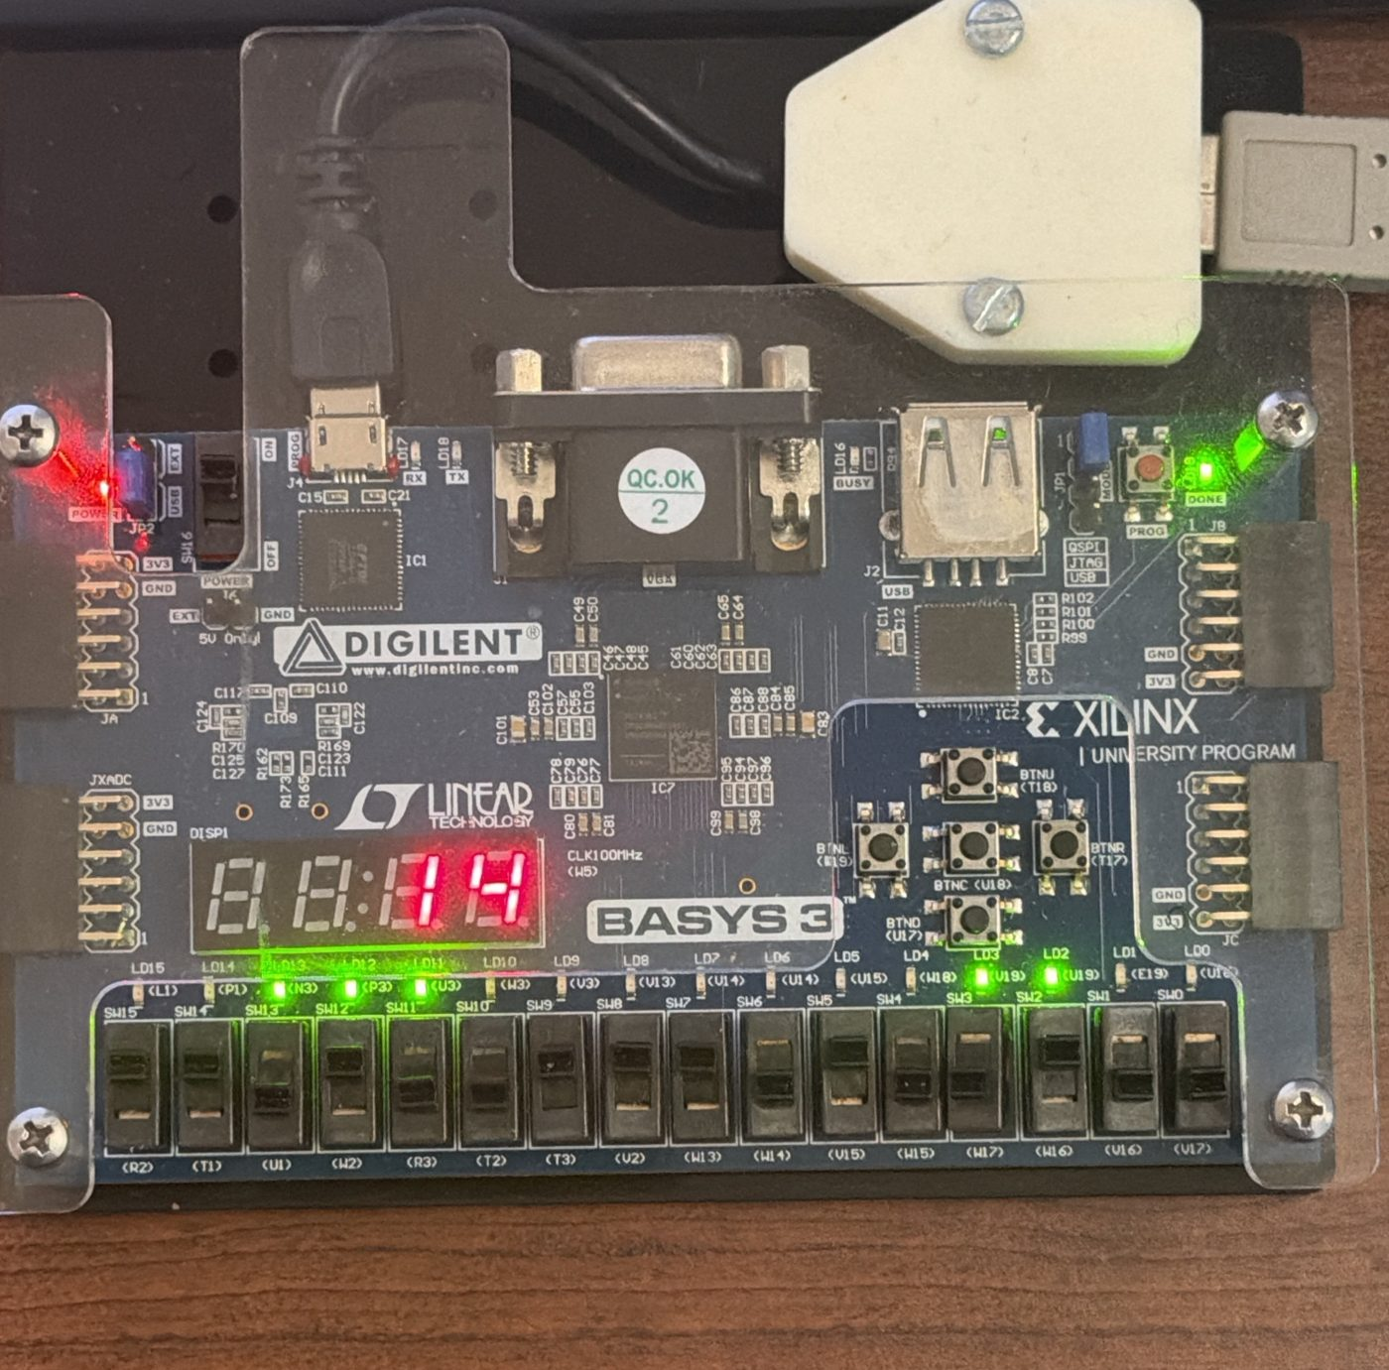  100 – A XOR B: display 14 | 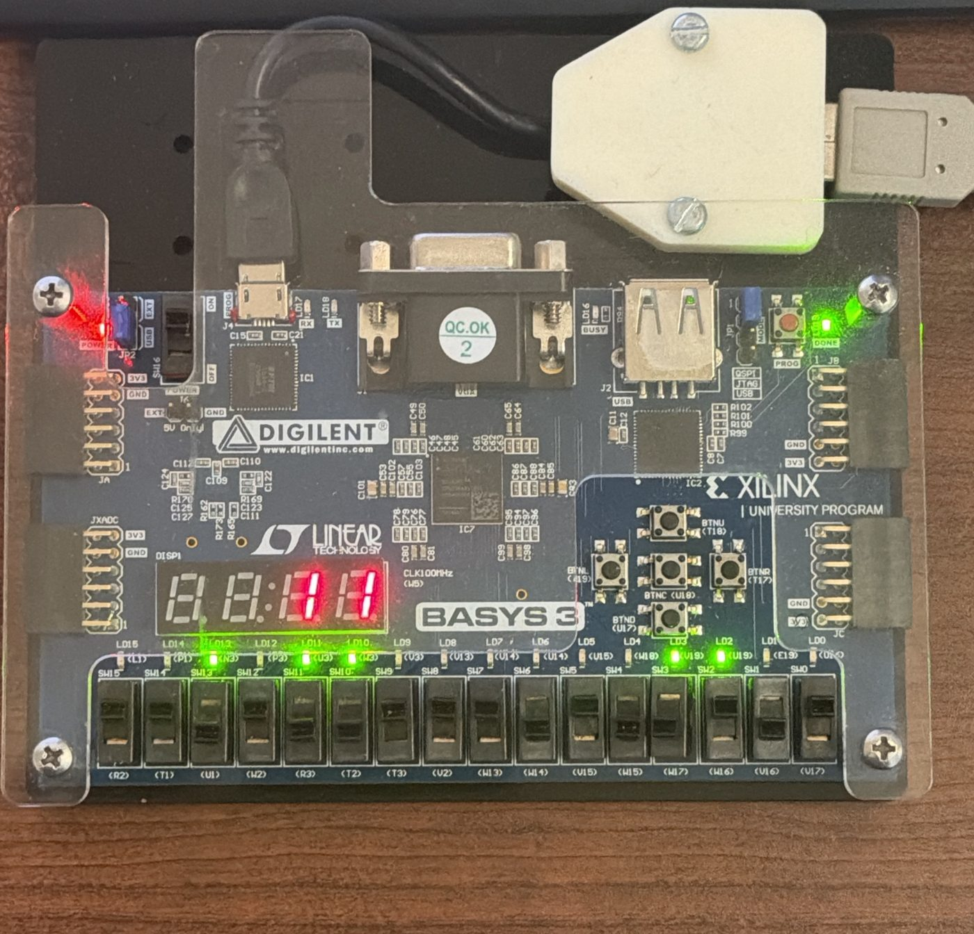  101 – NOT A: display 11
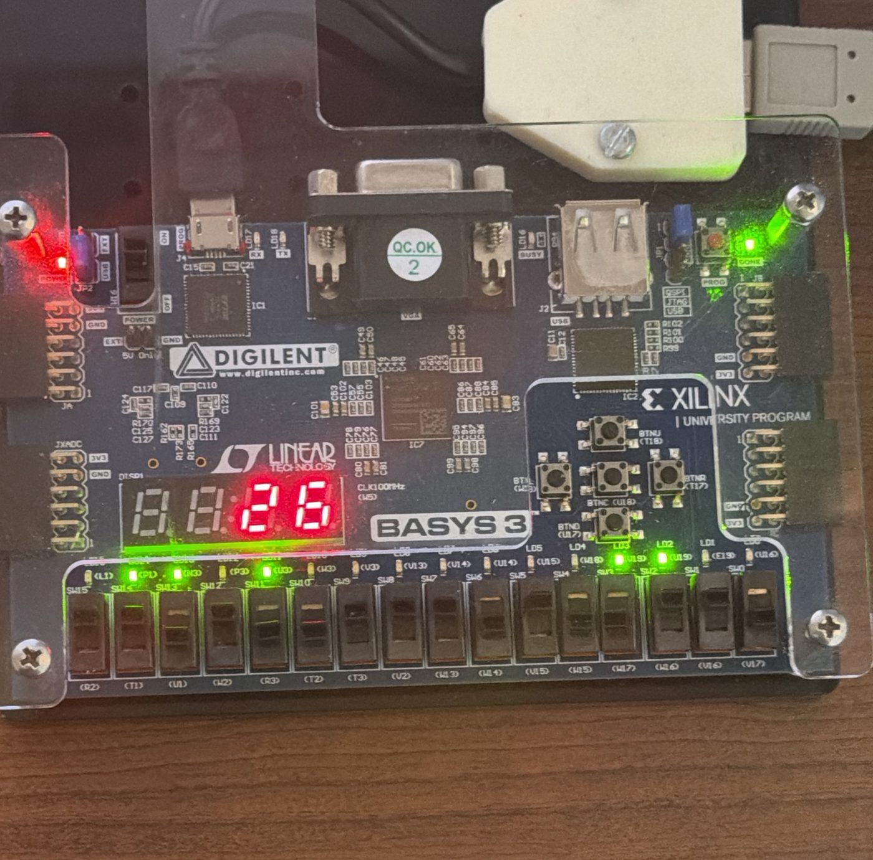  110 – Shift A right: display 26 | 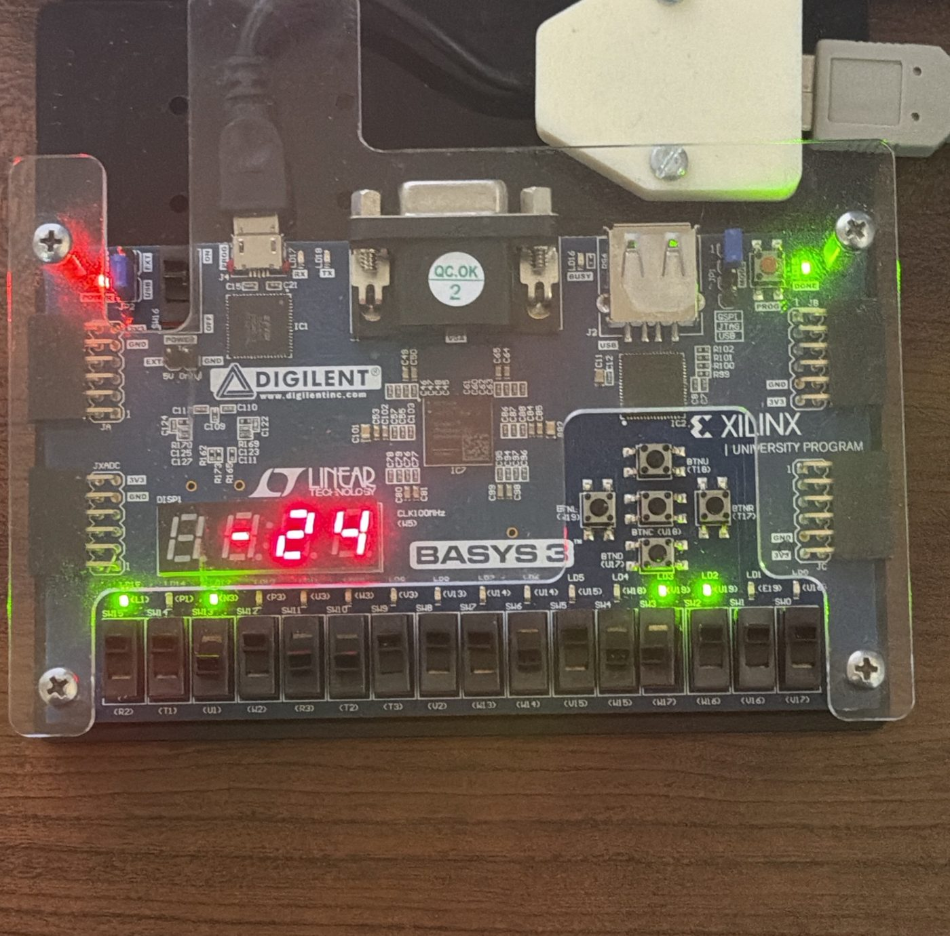  111 – Shift A left: display −24

